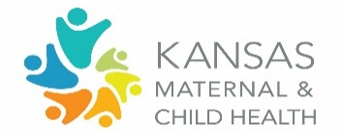
Title V Block Grant Review of Accomplishments and Data Trends
Domain Group: Child

Considering the information provided, answer the following questions:

Review the data for your population domain in the NOM/NPM/SPM Table. What trends stand out to you?
NOM’s: 13-15; 19-22.2 NPM’s: 6-8
What contributing factors may be associated with the trend you are seeing? Share any specific examples or stories related to contributing factors.
What emerging needs might impact this trend in the next couple of years? How might we address those?
Reflect on the upcoming activities from the State Plan in the Block Grant for your population domain, as presented today.
Upcoming Activities |  | What opportunities exist to elevate or further advance existing efforts? | What non-KDHE/Title V initiatives exist that align with these particular activities?
- Developmental Screening Parent Flyer
  - Dissemination to MCH grantees/home visitors, childcare providers, WIC providers, pediatricians, etc.

- Statewide ASQ Enterprise HUB
  - Establishing contracts across early childhood sectors
  - Partners include: Part C, Part B, home visiting; Head Start, schools, WIC, child care professionals, and Children Cabinet programs
  - Training to submit ASQ results into the state data platform

- Trainings
  - Ages and Stages Training statewide
  - Kan-Be-Healthy trainings for local health departments (on: KBH Orientation Manual, Bright Futures guidelines, online toolkit)

Looking at the plan overview for this domain, what is your commitment as a council member and the organization you represent to advance this plan? Share here: https://forms.gle/AJrBkeEHNfbjw25r7

